**Assignment-1**

**Name: SHIYAM R**

**Team ID:**PNT2022TMID17431

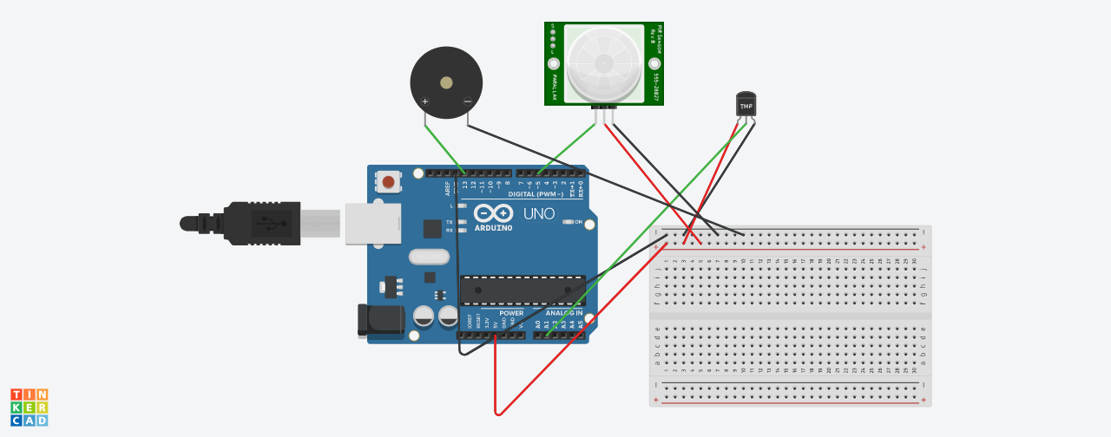

**CODE:**

int pirsensor =5;

int buzzer =13;

int pirvalue =0;

float temperature=A1;

float analog;

float voltage;

float celcius;

void setup()

{

pinMode(pirsensor, INPUT);

pinMode(temperature, INPUT);

pinMode(buzzer, OUTPUT);

Serial.begin(9600);

}

void loop()

{

analog=analogRead(temperature);

voltage=analog*5.0/1023;

celcius=(voltage-0.5)*100.0;

Serial.print("temperature:");

Serial.println(celcius);

if (celcius>=60)

{

tone(buzzer, 200, 100);

}

delay(100);

pirvalue = digitalRead(pirsensor);

if (pirvalue == HIGH)

{

tone(buzzer, 1000, 500);

}

delay(100);

}